AI-Powered Interactive Data Structures and Algorithms Visualizer with Integrated Python IDE

Akshat Yadav
Department of Information Technology
Acropolis Institute of Technology and Research, Indore, India
akshat33yadav@gmail.com

Archesh Shrivas
Department of Information Technology
Acropolis Institute of Technology and Research, Indore, India
archeshshrivas14@gmail.com

Abhinav Patidar
Department of Information Technology
Acropolis Institute of Technology and Research, Indore, India
abhinavpatidar230980@acropolis.in

Aditya Trivedi
Department of Information Technology
Acropolis Institute of Technology and Research, Indore, India
adityatri483@gmail.com

Aryan singh
Department of Information Technology
Acropolis Institute of Technology and Research, Indore, India
aryansinghgautum@gmail.com

Abstract
Data Structures and Algorithms (DSA) are fundamental concepts in computer science and software engineering. However, many students face difficulties in understanding algorithm behavior due to the abstract nature of execution processes and the lack of interactive learning environments. Traditional educational approaches primarily rely on theoretical explanations and static diagrams, which often fail to provide sufficient insight into internal algorithm operations. This paper presents an AI-Powered Interactive Data Structures and Algorithms Visualizer integrated with a browser-based Python IDE. The proposed system combines real-time code execution, step-by-step algorithm visualization, and Artificial Intelligence-based educational assistance into a unified learning platform. The frontend is developed using React.js and Monaco Editor, while FastAPI powers backend services. Python AST analysis and execution tracing are used to generate visualization states, and Google's Gemini 2.5 Flash model provides code explanations, complexity analysis, debugging guidance, and optimization recommendations. Experimental evaluation demonstrates that the platform enhances learner engagement, improves conceptual understanding, and provides intelligent support for learning algorithmic problem solving.
Keywords: Data Structures, Algorithms, Visualization, Artificial Intelligence, Gemini 2.5 Flash, FastAPI, React.js, Python IDE, Educational Technology.

I. INTRODUCTION
Data Structures and Algorithms form the foundation of efficient software development and computational problem solving. Mastery of these concepts is essential for programming, competitive coding, technical interviews, and advanced software engineering.
Despite their importance, students frequently encounter challenges while learning algorithms because internal execution processes remain invisible during runtime. Traditional learning methods such as textbooks, lectures, and static illustrations provide limited understanding of algorithm behavior and data manipulation.
Recent advancements in web technologies and Artificial Intelligence provide opportunities to transform algorithm education through interactive visualization and intelligent assistance. Visualization enables learners to observe execution behavior in real time, while Large Language Models can generate explanations, complexity analyses, and optimization recommendations.
The objective of this work is to develop a unified educational platform that integrates coding, execution, visualization, and AI-powered learning assistance within a single browser-based environment. The proposed system enables students to write Python programs, execute algorithms, visualize data structure operations, and receive AI-generated educational insights simultaneously. This integration significantly improves the overall learning experience and encourages active experimentation with algorithms.
Fig. 1. Project Interface Preview
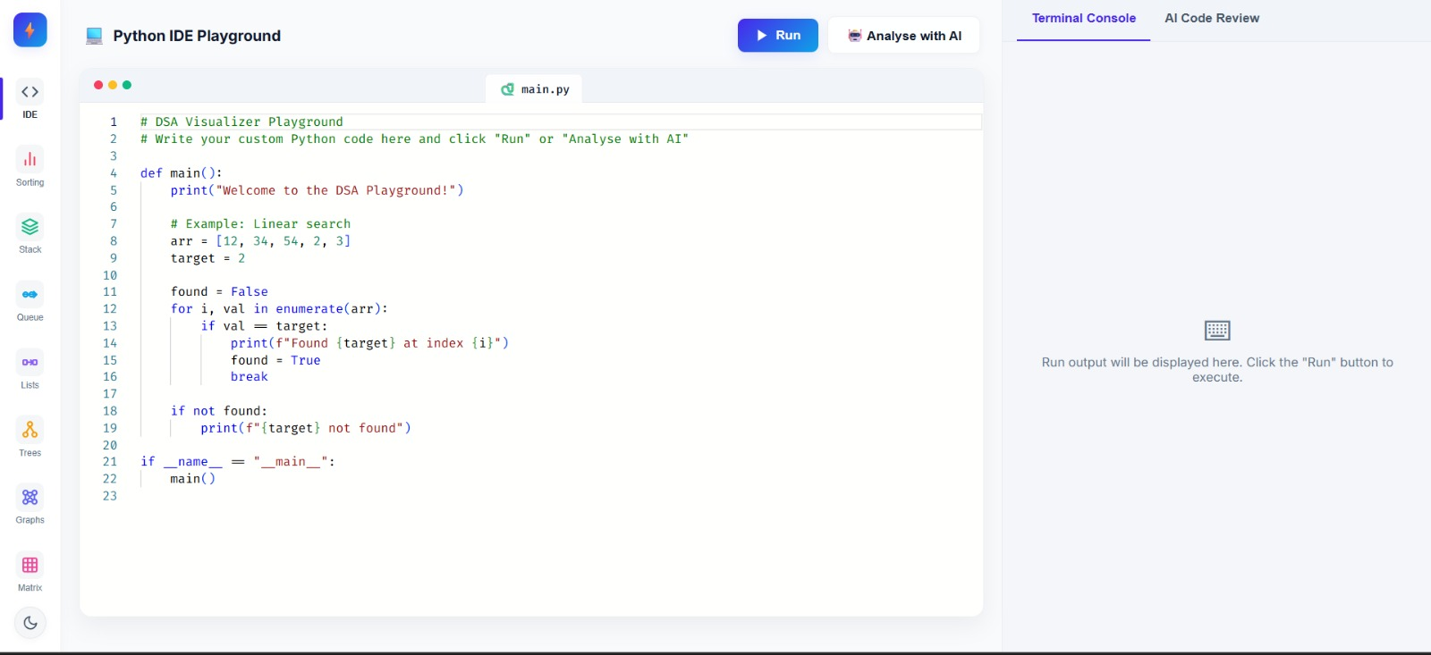

II. LITERATURE REVIEW
To understand the significance of the proposed platform, it is necessary to examine existing algorithm learning tools and their limitations.
A. Traditional DSA Learning Methods
Conventional educational approaches rely heavily on classroom teaching, textbooks, and static diagrams. While these methods explain theoretical concepts, they often fail to demonstrate how algorithms manipulate data during execution. Students frequently memorize algorithm implementations without fully understanding the underlying processes.
B. Existing Visualization Platforms
Several visualization tools such as VisuAlgo, Algorithm Visualizer, and educational simulation platforms provide graphical representations of algorithm execution. These tools improve conceptual understanding by illustrating sorting, searching, and traversal operations. However, most existing platforms do not allow users to write and execute their own code directly within the visualization environment.
C. AI-Based Educational Systems
Recent developments in Artificial Intelligence have introduced intelligent tutoring systems capable of generating code explanations, debugging suggestions, and educational guidance. Large Language Models such as Gemini and GPT-based systems have demonstrated remarkable capabilities in understanding programming logic and assisting learners.
D. Research Gap
Most existing solutions focus either on visualization or AI assistance. Visualization tools generally lack personalized educational feedback, while AI coding assistants do not provide interactive visual representations of algorithm behavior. The absence of an integrated environment limits their educational effectiveness.
The proposed system addresses this gap by combining code execution, visualization, and AI-powered educational support within a single unified platform.

III. SYSTEM ARCHITECTURE
The proposed platform follows a modular architecture designed to ensure scalability, maintainability, and efficient communication among system components.
The architecture consists of the following major modules:
- React.js Frontend
- Monaco Editor
- FastAPI Backend
- Execution Tracing Engine
- Visualization Module
- Gemini 2.5 Flash AI Engine
The frontend provides an interactive coding environment where users can write Python programs. User requests are forwarded to the backend through REST APIs. The backend executes the code, generates execution traces, and communicates with the Gemini AI service.
The execution tracing engine utilizes Python AST analysis and runtime tracing mechanisms to monitor algorithm behavior. Generated execution states are forwarded to the visualization engine, which converts them into graphical representations and animations.
Simultaneously, source code is analyzed using Gemini 2.5 Flash to generate algorithm explanations, complexity evaluations, debugging guidance, and optimization recommendations. All outputs are integrated into a unified learning dashboard.
Fig. 2. Overall System Architecture
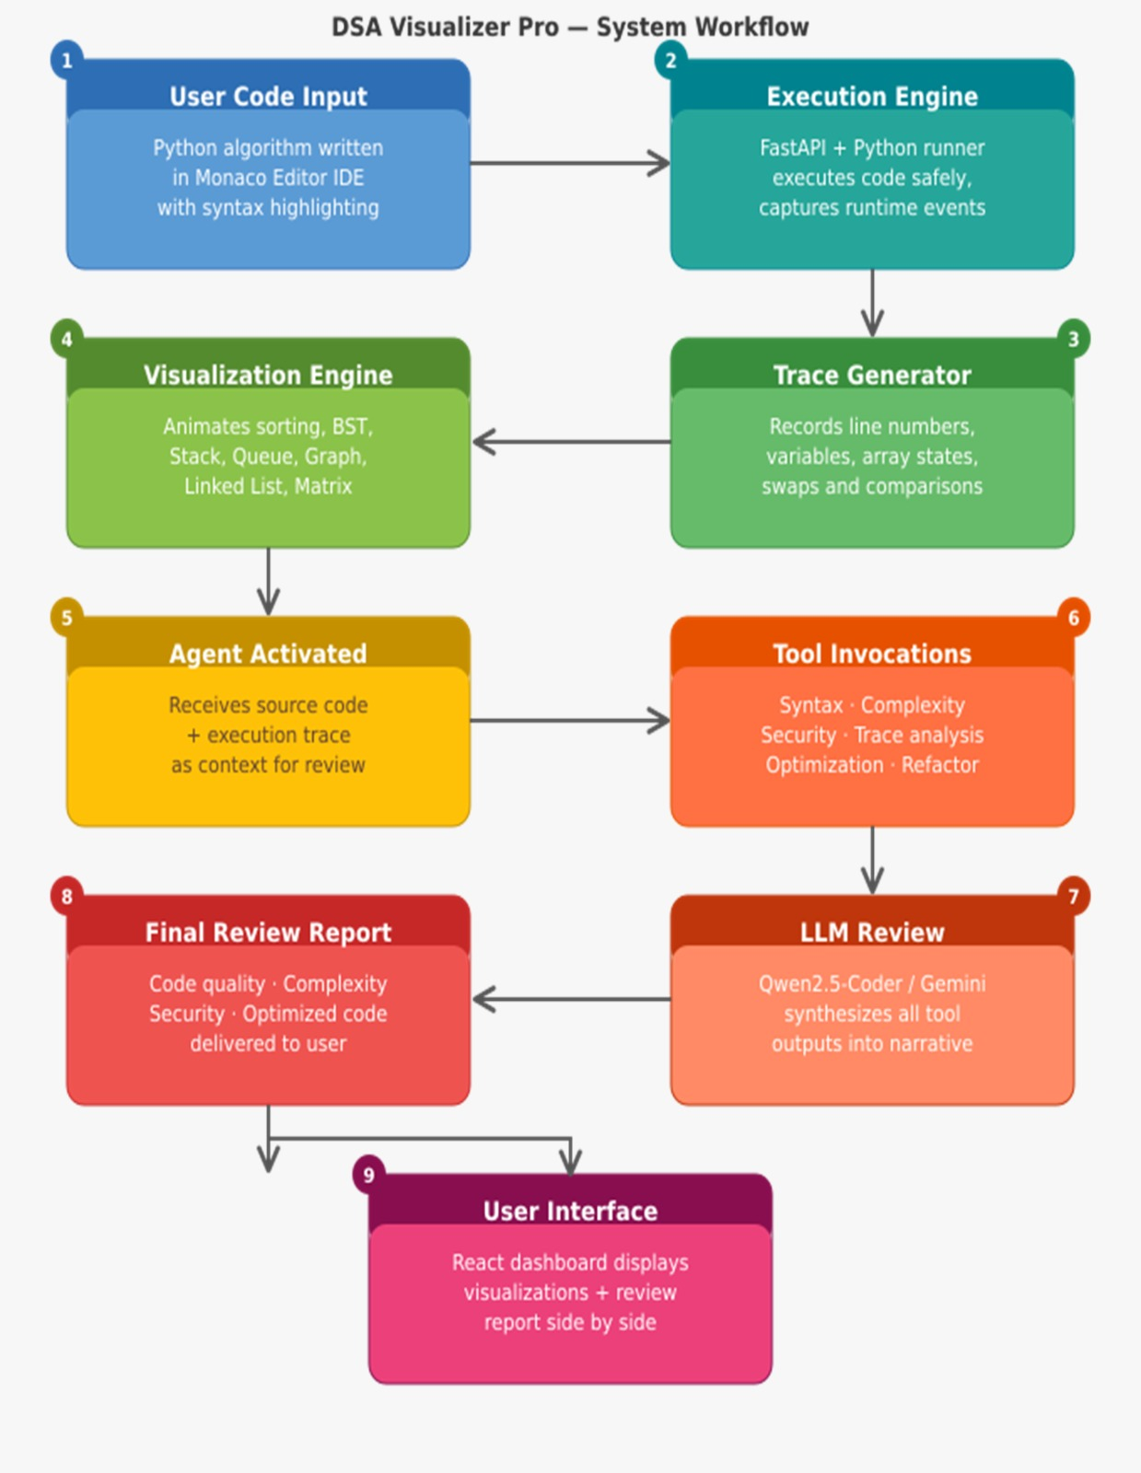

IV. METHODOLOGY
The proposed methodology follows a structured educational workflow designed to improve learner understanding of Data Structures and Algorithms.
A. Code Development
Users write Python programs within the Monaco-based Integrated Development Environment. The editor provides syntax highlighting, indentation support, and an interface similar to Visual Studio Code.
B. Code Submission and Execution
The submitted code is sent to FastAPI backend services. Input validation and preprocessing are performed before execution begins.
C. Execution Trace Generation
The system uses Python Abstract Syntax Trees (AST) and sys.settrace mechanisms to monitor program execution. Runtime events such as comparisons, assignments, swaps, and state transitions are recorded.
D. Visualization Generation
Execution states generated during tracing are transformed into graphical visualizations. The visualization engine displays algorithm operations through animations and dynamic state transitions.
E. AI-Based Educational Analysis
The submitted code is simultaneously forwarded to the Gemini 2.5 Flash model through the Google GenAI SDK. The AI engine performs:
- Algorithm explanation
- Code quality assessment
- Time complexity analysis
- Space complexity analysis
- Debugging assistance
- Optimization recommendation generation
F. Learning Dashboard Presentation
Visualization outputs, execution results, and AI-generated educational insights are combined and displayed through a unified learning dashboard.

Fig. 3. System Workflow Diagram
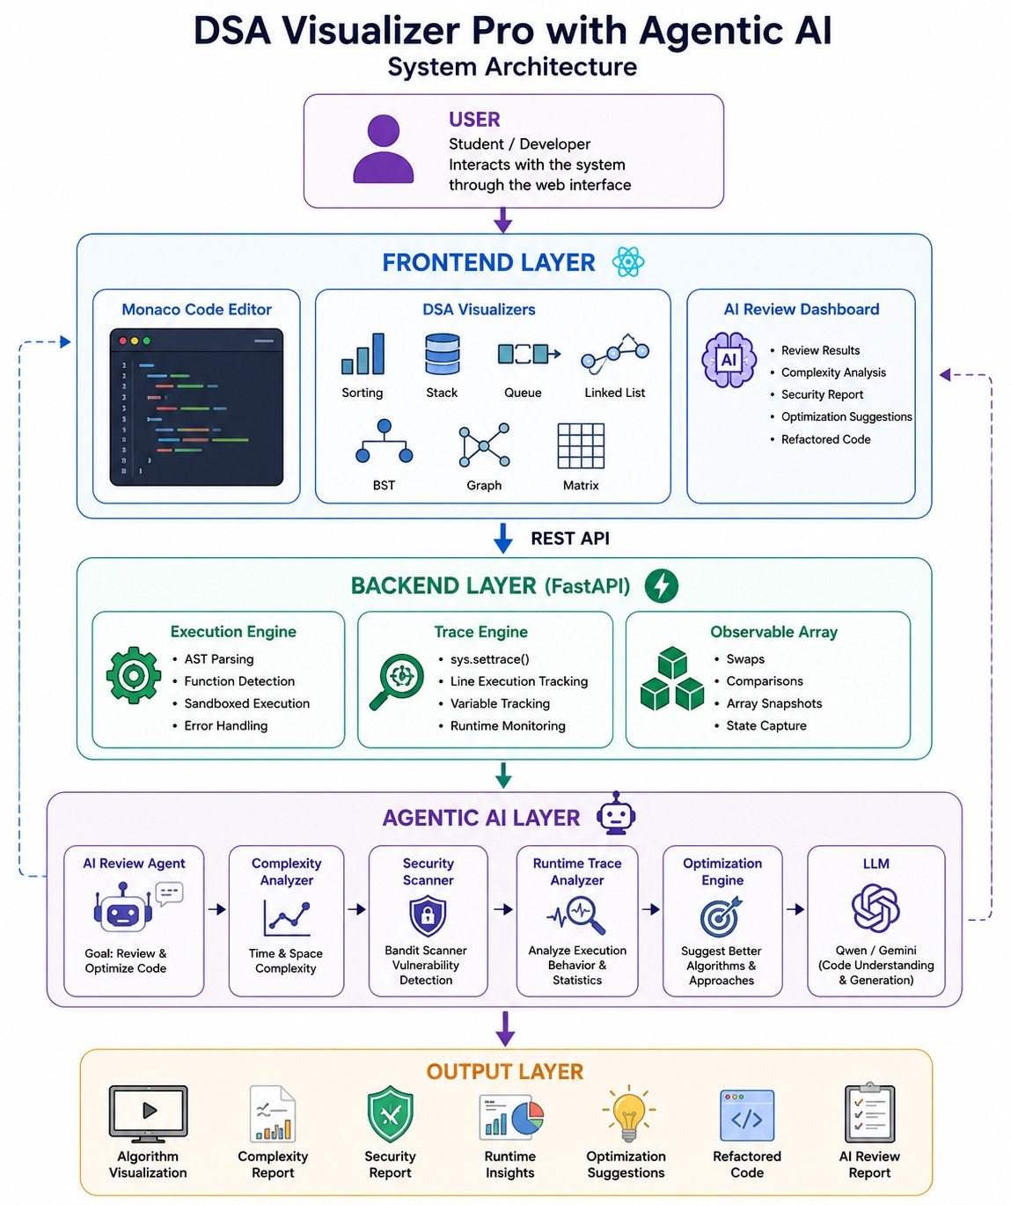

V. IMPLEMENTATION
The implementation of the proposed platform focuses on integrating visualization, code execution, and Artificial Intelligence into a browser-based educational environment.
A. Frontend Implementation
The frontend application was developed using React 18.3 and Vite 5.3. React's component-based architecture allows modular development and efficient user interface management. Vite provides fast development and build performance.
Monaco Editor was integrated as the primary coding interface. The editor provides syntax highlighting, automatic indentation, intelligent editing features, and a professional coding experience comparable to Visual Studio Code.
Custom CSS3, Flexbox, CSS Grid, and animation frameworks were used to create responsive layouts and visualization effects.
B. Backend Implementation
Backend services were developed using Python and FastAPI. FastAPI was selected due to its high performance, asynchronous support, and automatic API documentation generation.
Pydantic models validate incoming requests and maintain data consistency throughout processing. Uvicorn serves as the ASGI server responsible for running backend services.
C. Visualization Engine
The visualization engine utilizes Python AST parsing and sys.settrace execution monitoring. Runtime states are captured and converted into structured visualization data. React components render these states through animations representing comparisons, swaps, insertions, and other algorithm operations.
D. AI Integration Module
Artificial Intelligence functionality is implemented through the Google GenAI SDK. Gemini 2.5 Flash serves as the primary model, while Gemini 2.5 Flash Lite and Gemini Flash Lite Latest provide fallback support during periods of high traffic.
The AI subsystem generates structured educational reports containing explanations, complexity evaluations, debugging suggestions, and optimized code recommendations.

VI. EXPERIMENTAL EVALUATION
The developed platform was tested using multiple Data Structures and Algorithms implementations including sorting algorithms, searching algorithms, and array manipulation operations.
The evaluation focused on:
- Code execution accuracy
- Visualization correctness
- AI response quality
- User interface responsiveness
- System integration reliability
Table I. Functional Evaluation Results
Feature | Result
Python Code Execution | Successful
Visualization Generation | Successful
Algorithm Explanation | Successful
Complexity Analysis | Successful
Debugging Assistance | Successful
Optimization Suggestions | Successful
API Communication | Successful
User Interface Responsiveness | Successful
The obtained results confirm that all major functionalities operate correctly and satisfy the project objectives.

VII. RESULTS AND DISCUSSION
The experimental results demonstrate that the proposed platform successfully integrates visualization and Artificial Intelligence into a unified educational environment.
The visualization engine effectively converts algorithm execution states into graphical representations, enabling users to observe internal operations such as comparisons, swaps, insertions, and state transitions. This significantly improves conceptual understanding compared to traditional text-based learning methods.
The integration of Gemini 2.5 Flash provides substantial educational value. The AI system successfully generates:
- Algorithm explanations
- Time complexity analysis
- Space complexity analysis
- Debugging guidance
- Code optimization recommendations
These insights help learners understand not only how algorithms operate but also how implementations can be improved for performance and readability.
Performance testing demonstrated smooth frontend responsiveness and reliable backend processing. FastAPI and Uvicorn efficiently handled code execution requests, while Gemini responses were generated within acceptable educational timeframes.
The results indicate that combining visualization and Artificial Intelligence creates a more engaging and effective learning environment for Data Structures and Algorithms education.

VIII. CONCLUSION AND FUTURE SCOPE
This paper presented an AI-Powered Interactive Data Structures and Algorithms Visualizer integrated with a browser-based Python IDE and Artificial Intelligence learning assistant. The developed platform successfully combines code execution, visualization, and AI-assisted educational support within a unified web-based learning environment.
The system addresses several challenges faced by students while learning algorithms by providing real-time visual representations and intelligent explanations. Experimental evaluation confirmed the effectiveness of the proposed solution in improving learner engagement, algorithm understanding, and educational accessibility.
The integration of React.js, FastAPI, Monaco Editor, AST-based execution tracing, and Gemini 2.5 Flash demonstrates the feasibility of combining modern web technologies and Artificial Intelligence for educational applications.
Future enhancements may include support for additional programming languages such as Java, C++, and JavaScript. Advanced visualizations for graph algorithms, tree structures, dynamic programming techniques, and complex data structures can also be incorporated. Additional features such as user authentication, progress tracking, collaborative learning environments, and personalized AI-driven recommendations may further improve educational effectiveness.
The results obtained in this work demonstrate that AI-assisted visualization platforms represent a promising direction for the future of computer science education.

IX. FUTURE WORK
Future development of the proposed platform may focus on several important areas:
A. Multi-Language Support
Support for programming languages such as Java, C++, JavaScript, and Go can be added to increase platform accessibility.
B. Advanced Data Structure Visualization
Future versions may include visualizations for:
- AVL Trees
- Red-Black Trees
- Heaps
- Tries
- Graph Algorithms
- Dynamic Programming Problems
C. Personalized Learning Assistance
Artificial Intelligence can be extended to provide personalized learning recommendations based on user performance and coding behavior.
D. Collaborative Learning Environment
Real-time collaborative coding and visualization sessions can support classroom learning and team-based education.
E. User Progress Tracking
User accounts and progress monitoring systems can be integrated to track learning achievements and educational growth.

REFERENCES
[1] T. H. Cormen, C. E. Leiserson, R. L. Rivest, and C. Stein, Introduction to Algorithms, MIT Press.
[2] Google AI, Gemini API Documentation, Google Developers.
[3] React Documentation, Meta Platforms Inc.
[4] FastAPI Documentation, Sebastián Ramírez.
[5] Monaco Editor Documentation, Microsoft Corporation.
[6] Python Software Foundation, Python Official Documentation.
[7] M. Fowler, Refactoring: Improving the Design of Existing Code, Addison-Wesley.
[8] R. Sedgewick and K. Wayne, Algorithms, Addison-Wesley.
[9] Educational Visualization Research in Computer Science Learning Environments.
[10] Research on AI-Assisted Programming Education and Intelligent Tutoring Systems.

